# **Coding practice Problems:** 13.11.2024 **Name: VAITHIYANATHAN T Dept :CSE**

# 

1. K smallest element in the given array

CODE :

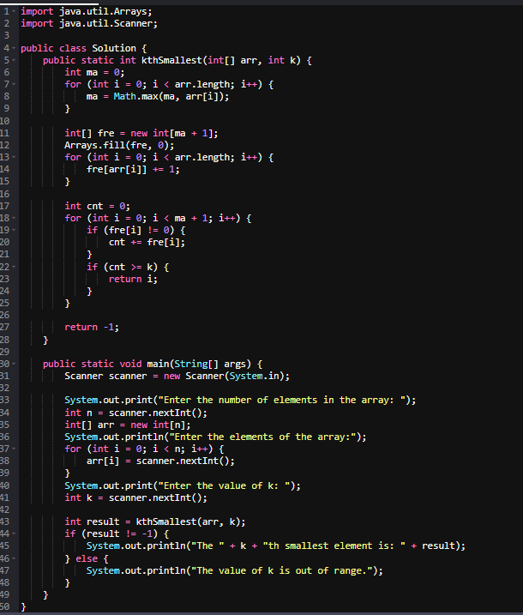

Output :

Enter the number of elements in the array: 6

Enter the elements of the array:

3 1 2 1 4 5

Enter the value of k: 3

The 3th smallest element is: 2

**Time Complexity** : O(n + m) where m is the max element in the array

**Space Complexity** : O(m)

2. Minimize the Heights II

CODE:

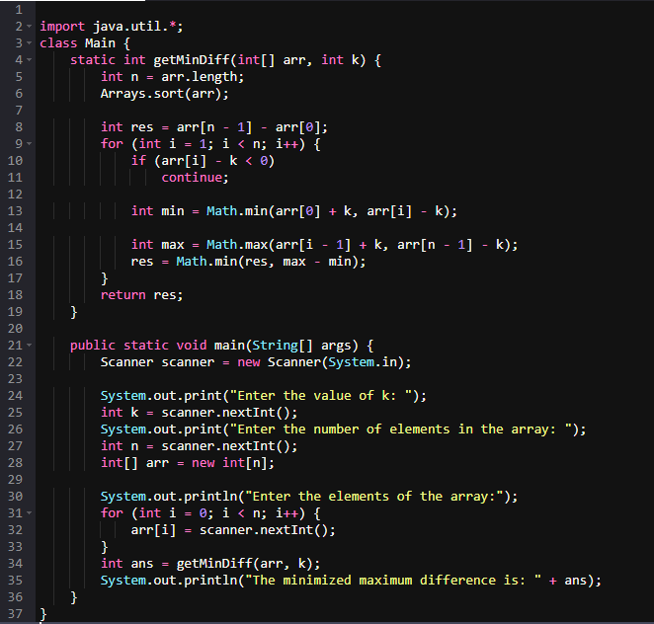  
Output :

Enter the value of k: 6

Enter the number of elements in the array: 6

Enter the elements of the array: 12 6 4 15 17 10

The minimized maximum difference is: 9

Time Complexity: O(n logn)

Space Complexity: O(n)

3. Parenthesis Checker

CODE :

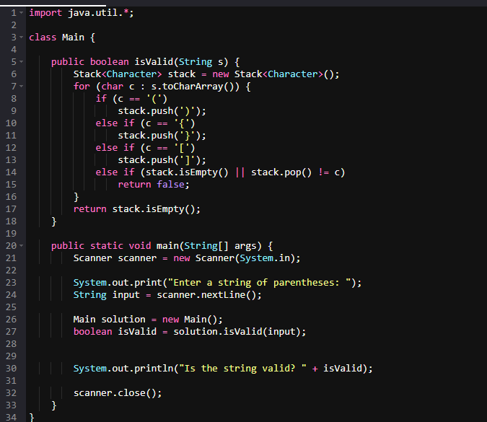

Output:

Enter a string of parentheses: {}(){}

Is the string valid? True

Time Complexity: O(n)

Space Complexity: O(n)

4. Equilibrium Point

CODE :

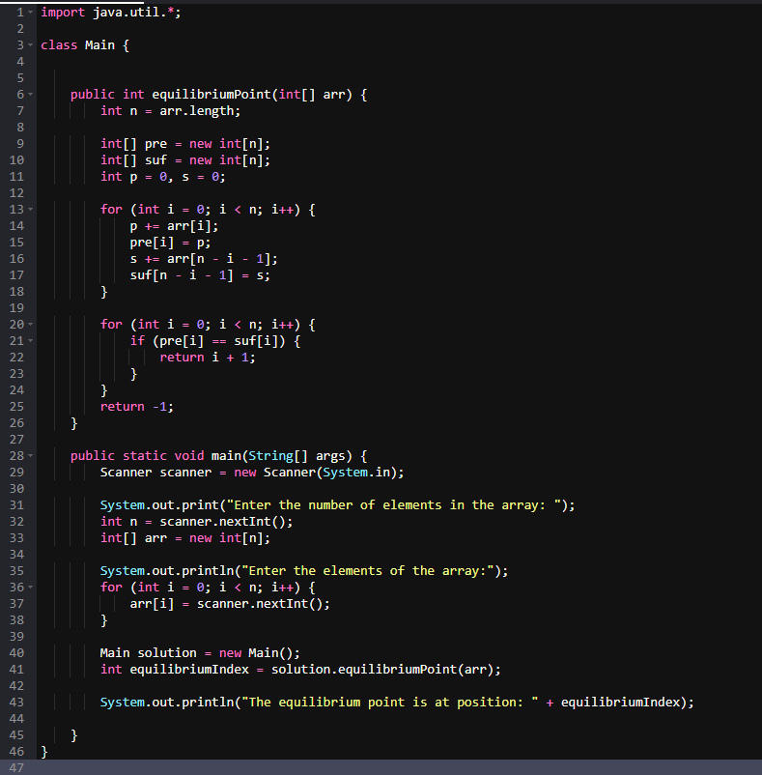

Output:

Enter the number of elements in the array: 4

Enter the elements of the array:

1 2 3 4

The equilibrium point is at position: -1

Time Complexity: O(n)

Space Complexity : O(2n) à O(n)

5 . Binary Search

CODE :

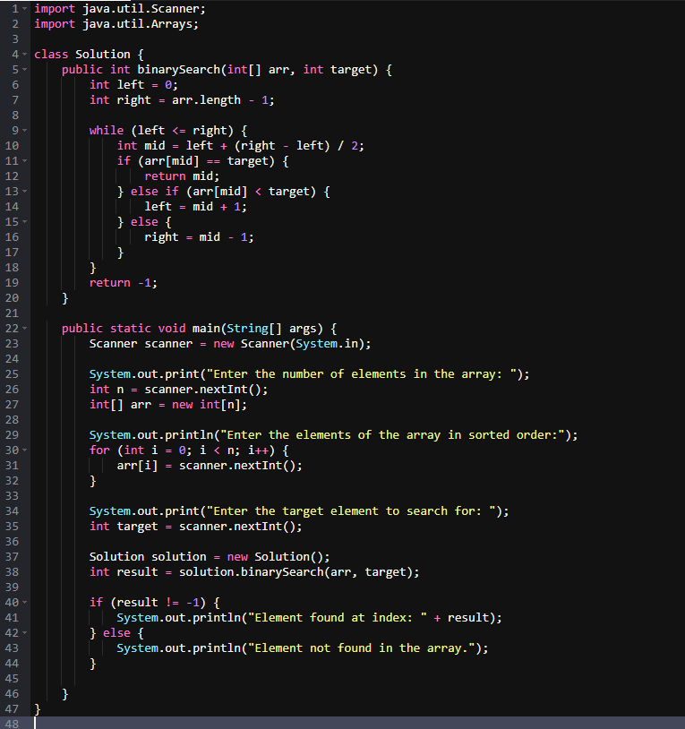Output:

Enter the number of elements in the array: 5

Enter the elements of the array in sorted order:

1 3 5 7 9

Enter the target element to search for: 5

Element found at index: 2

Time Complexity : O(log n)

Space Complexity : O(1)

6 . **Union of Two Arrays with Duplicate Elements**

CODE :

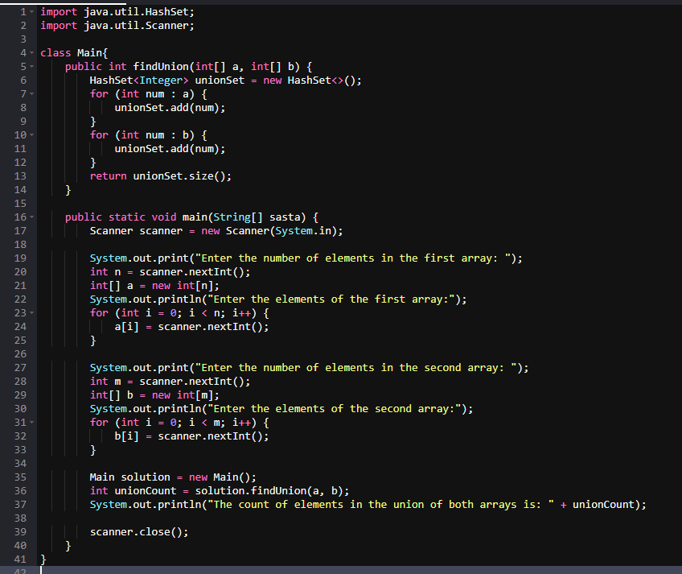

Output :

Enter the number of elements in the first array: 4

Enter the elements of the first array:

1 2 3 4

Enter the number of elements in the second array: 5

Enter the elements of the second array:

3 4 5 6 7

The count of elements in the union of both arrays is: 7

Time Complexity: O(n)

Space Complexity : O(n)